# THEME

Automation for Human Well-being

Automation has revolutionized various aspects of human life, improving convenience, efficiency, and overall well-being. The theme "Automation for Human Well-Being" focuses on integrating intelligent systems and automated solutions to enhance the quality of life, reduce human effort, and promote safety, health, and accessibility. By leveraging technologies such as Artificial Intelligence, Robotics, Internet of Things, and Machine Learning, automation is playing a crucial role in improving daily tasks, healthcare, industries, and smart living environments.

The essence of this theme lies in developing cost-effective, intelligent, and reliable automation solutions that cater to diverse human needs—ranging from healthcare and personal assistance to smart homes, agriculture, and retail services. Through automation, society can overcome inefficiencies, reduce errors, and create a more inclusive and sustainable future for everyone.

Benefits of Automation for Human Well-Being

1. Reduces Human Effort and Fatigue – Allows people to focus on creative and strategic tasks instead of repetitive labor.
2. Increases Accessibility – Provides assistive solutions for individuals with disabilities and the elderly.
3. Improves Accuracy and Consistency – Reduces human errors in manufacturing, healthcare, and daily tasks.
4. Saves Time and Costs – Enhances operational efficiency and minimizes expenses in various sectors.
5. Boosts Quality of Life – Smart automation in homes, healthcare, and retail improves user convenience.
6. Enhances Safety – Reduces workplace hazards and ensures security in public spaces through surveillance automation.

The future of automation for human well-being is driven by rapid advancements in AI, robotics, and IoT, shaping a world where technology seamlessly integrates into daily life. From healthcare and smart homes to industries and transportation, automation will enhance efficiency, safety, and accessibility. From healthcare and smart homes to industries and transportation, automation will enhance efficiency, safety, and accessibility. AI-powered healthcare will improve diagnostics and patient care, while autonomous systems will revolutionize mobility and workplace productivity. Personalized automation will cater to individual needs, making life more convenient and efficient. Personalized automation will cater to individual needs, making life more convenient and efficient. As automation continues to evolve, it will create a future that is smarter, safer, and more inclusive, ultimately enhancing the overall quality of human life.

# Problem Identification

Traditional shopping experiences often involve long queues at billing counters, manual scanning of products, and difficulties in budget management. Customers must wait for cashiers to scan each item individually, leading to delays and inconvenience, especially in crowded supermarkets. Additionally, keeping track of expenses while shopping can be challenging, as customers may unintentionally exceed their budget. Another major challenge arises for elderly individuals, carrying women, and disabled shoppers, who may struggle with pushing carts, managing items, and navigating through congested store aisles. These inefficiencies highlight the need for an automated shopping solution that simplifies the process, enhances convenience, and improves store management.

Need for Solving This Problem

1. Eliminating Long Checkout Queues
   * The conventional checkout process is time-consuming and frustrating for customers. Automating the billing system can significantly reduce waiting times, enhancing the overall shopping experience.
2. Real-Time Budget Management
   * Customers often struggle with overspending due to a lack of real-time bill tracking. The smart shopping cart provides instant billing updates, allowing users to stay within their budget.
3. Convenience for Special Needs Customers
   * Elderly individuals, pregnant women, and people with disabilities often face difficulties in handling shopping carts and managing purchases. A mobile- controlled cart ensures a smoother, hassle-free experience.
4. Enhanced Store Efficiency and Security
   * RFID-based scanning eliminates the need for manual barcode scanning, making item identification faster and more accurate.
5. Obstacle Detection for Smooth Navigation
   * The inclusion of an ultrasonic sensor allows the cart to detect obstacles and stop accordingly, preventing collisions and ensuring safe movement within the store.

The smart shopping cart with automatic billing not only enhances the efficiency of shopping but also contributes to a more inclusive, secure, and technology-driven retail experience.

# Introduction to Design Thinking

The Design Thinking phase involves understanding user needs, defining the problem, and creating a user-friendly solution to enhance the shopping experience with automation.

Design Thinking is a human-centered approach to problem-solving that focuses on understanding users' needs, defining the problems clearly, ideating innovative solutions, prototyping, and testing to refine ideas. The process is iterative, flexible, and fosters creativity while ensuring practical, effective outcomes. It involves five key phases: Empathize, Define, Ideate, Prototype, and Test.

1. Empathize: In this phase, the goal is to deeply understand the users and their needs. Through research and interaction, designers gain empathy, identifying the problems and emotions involved.
2. Define: This phase focuses on synthesizing the findings from the empathize phase to define the core problem. A clear problem statement is created that guides the design process.
3. Ideate: Designers brainstorm a variety of possible solutions. This phase encourages creativity and generates multiple ideas to tackle the defined problem.
4. Prototype: In this phase, designers create low-cost, tangible representations of the ideas. Prototypes are developed to explore solutions and see how they work in practice.
5. Test: Testing involves getting feedback on the prototypes and iterating on the solutions. It's an opportunity to refine ideas and adjust based on user interaction and feedback.

## Stakeholder Map

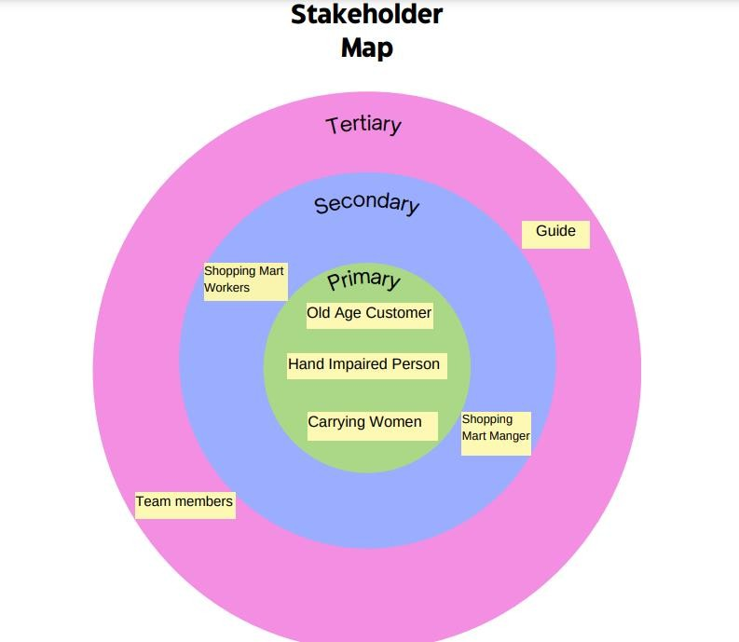

Fig 3.1

The stakeholder map depicted in the image categorizes stakeholders involved into three tiers: Primary, Secondary, and Tertiary.

* Primary Stakeholders: These are the direct users who will benefit the most.

Users who benefit the most, such as elderly customers, hand-impaired individuals, and carrying women, who need convenience and ease while shopping.

* Secondary Stakeholders: These stakeholders interact with the system but are not the primary users. Indirect users like shopping mart managers and workers, who interact with the system for maintenance and ensuring customer satisfaction.
* Tertiary Stakeholders: These individuals provide support or indirectly influence the system’s development. Supportive roles, including our guide, providing mentorship and the team members developing and refining the prototype.

## Stakeholder Personas

Stakeholder personas are detailed representations of the key users or groups involved in the project, reflecting their behaviours, goals, and challenges. These personas help in understanding the needs and motivations of stakeholders, ensuring that the design process aligns with their expectations.

3.2a Primary Stakeholder-1

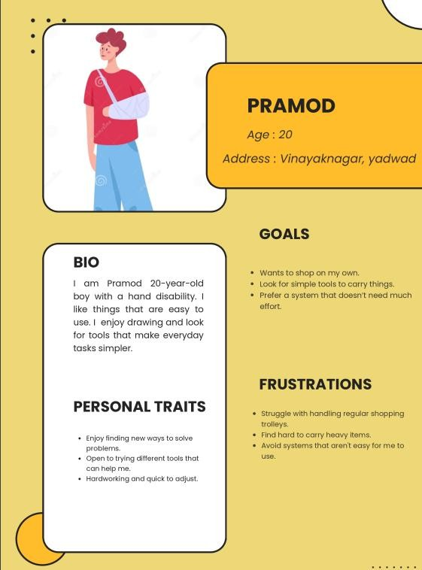

Fig 3.2a

3.2b Primary Stakeholder-2

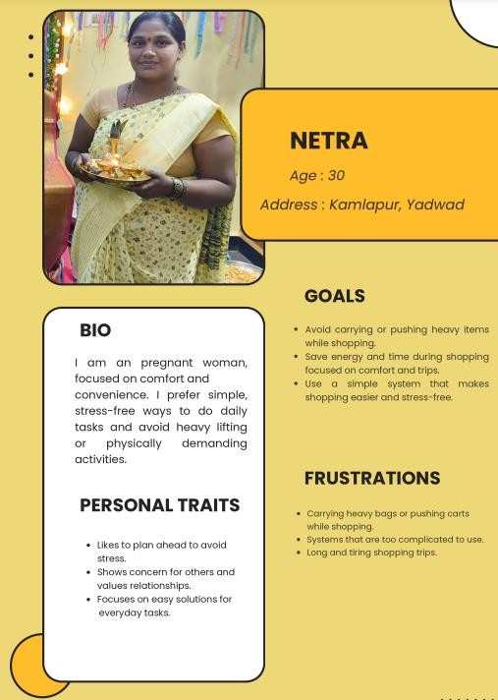

Fig 3.2.b

3.2c Primary Stakeholder-3

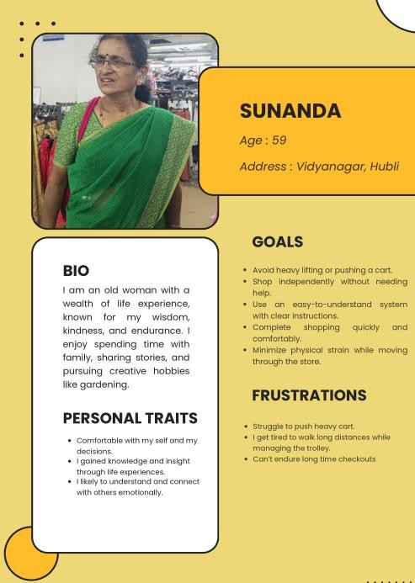

Fig 3.2c

3.2d Secondary Stakeholder-1

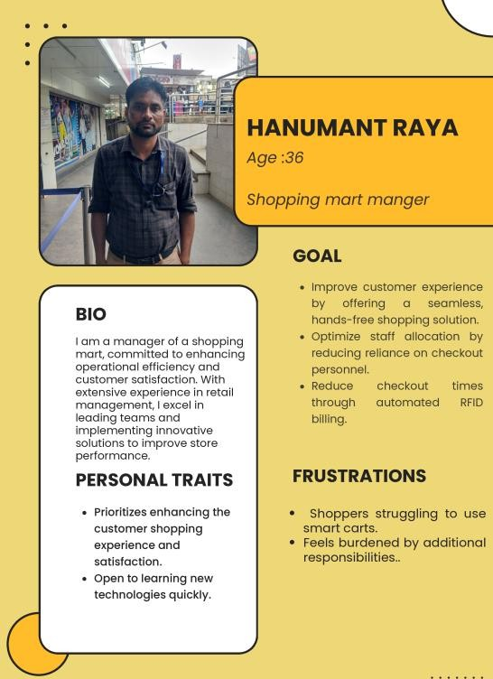

Fig 3.2d

* 1. e Secondary Stakeholder-2

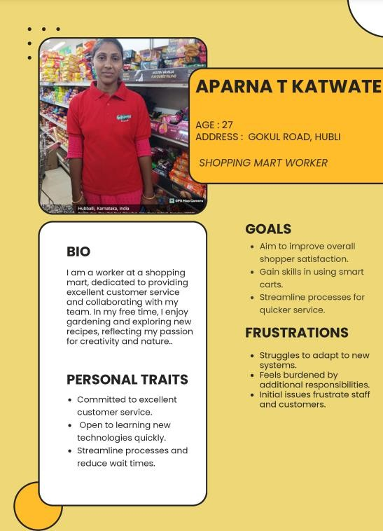

Fig 3.2e

* 1. f Tertiary Stakeholders-1

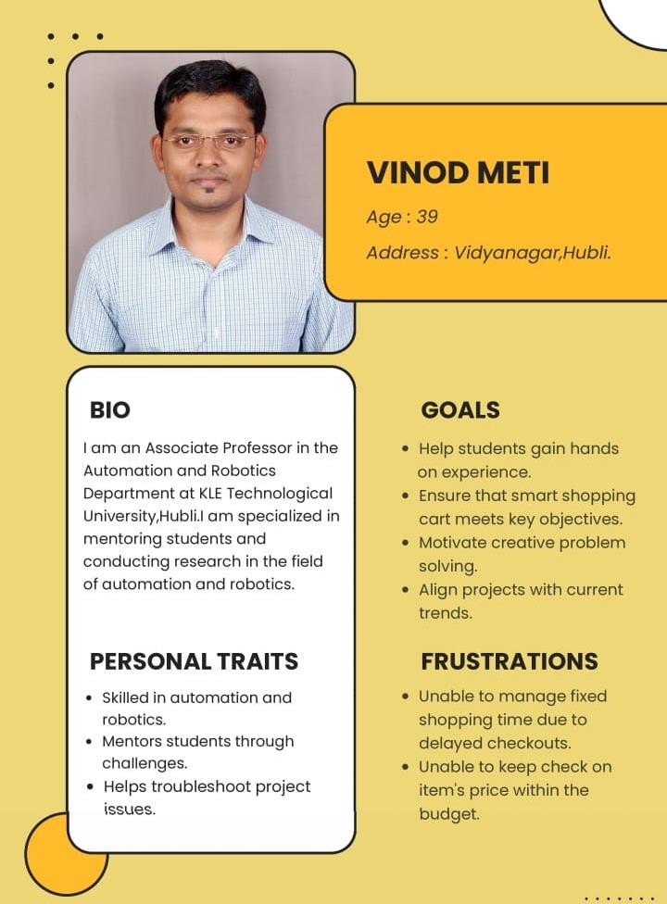

Fig 3.2f

* 1. g Tertiary Stakeholders-2

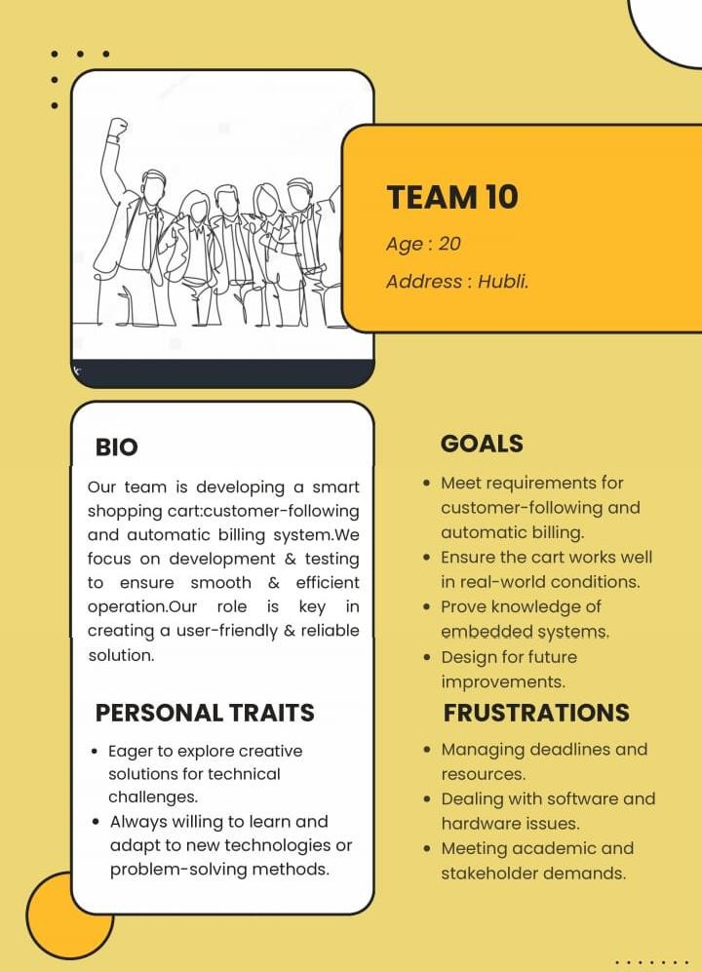

Fig 3.2g

## 3.3 Empathy Map

* 1. a Primary Stakeholder Empathy Map (Customers)

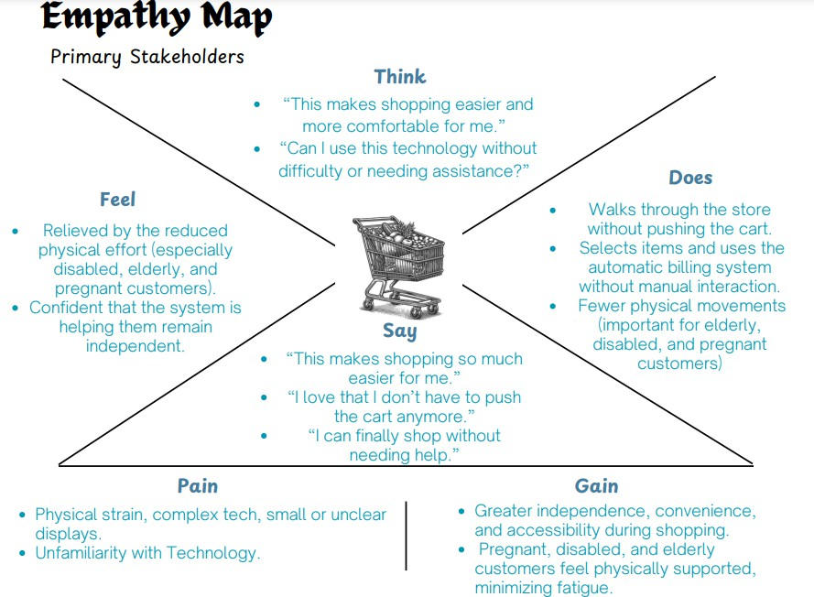

Fig 3.3a

This map reveals that primary stakeholders (customers) are excited about the potential for increased convenience and independence while shopping. They appreciate the reduced physical strain, especially those with mobility challenges. However, concerns about technology usability and potential technical difficulties need to be addressed to ensure a positive user experience.

* 1. b Secondary Stakeholder Empathy Map (Workers & Managers)

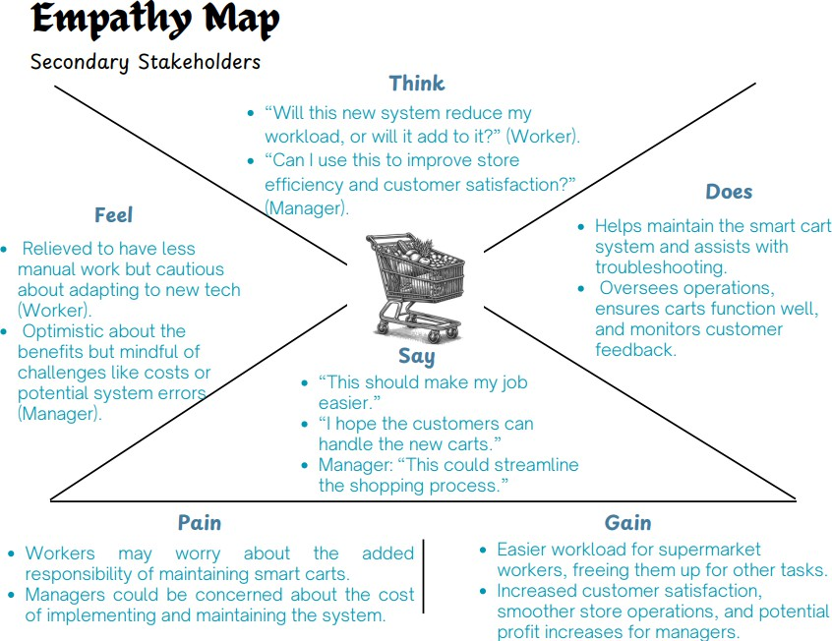

Fig 3.3b

This map focuses on the secondary stakeholders (workers and managers) and their reactions to the new smart cart system. Workers are cautiously optimistic, hoping for an easier workload but concerned about new responsibilities and customer adoption. Managers are focused on efficiency and cost, hoping for improved customer satisfaction and profit but mindful of implementation challenges.

* 1. cTertiary Stakeholder Empathy Map (Project Team - Members & Guide)

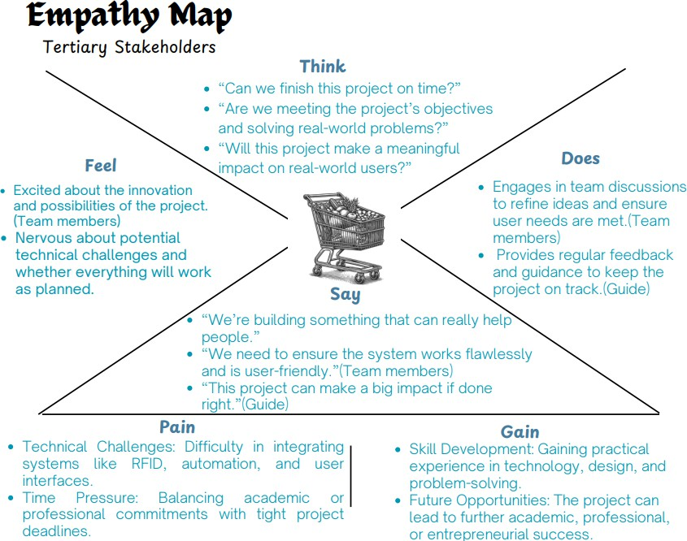

This map explores the perspective of the tertiary stakeholders (project team). Team members are driven by the potential for innovation and positive impact, but face pressures related to technical challenges and deadlines. The guide emphasizes the project's potential for significant impact. The map highlights the importance of skill development and future opportunities as motivating factors.

## User need Statements

|  |  |
| --- | --- |
| SL NO | Need Statements |
| 1 | The customer needs a shopping cart that can be controlled seamlessly through a mobile application. |
| 2 | The customer needs a cart that identifies items using a scanner as they are added to the cart. |
| 3 | The customer needs a cart that displays the total bill in real-time on the screen. |
| 4 | The customer needs a cart that eliminates the need for manual scanning at checkout. |
| 5 | The customer needs a shopping cart that requires minimal human interaction. |
| 6 | The customer needs a cart that syncs with the app to provide alerts if they move too far from the cart. |
| 7 | The customer needs a cart that can detect obstacles and navigate around them safely. |
| 8 | The customer needs a cart that functions smoothly and provides a jerk-free shopping experience. |
| 9 | The customer needs a shopping cart that alerts them to expired or recalled products because it ensures safe purchases. |
| 10 | The customer needs a cart that must allow misadded item removal. |
| 11 | The customer needs a cart that is energy-efficient to support longer shopping sessions. |
| 12 | The customer needs a cart that helps reduce wait times at checkout. |
| 13 | The customer needs a cart with a large, easy-to-read display for convenient bill viewing. |
| 14 | The customer needs a cart that can accommodate different item weights and sizes while maintaining balance. |
| 15 | The customer needs a cart that can navigate various floor types (carpet, tile, etc.) smoothly. |
| 16 | The customer needs a cart that navigates according to shopping mart map. |
| 17 | The customer needs a cart that offers a user-friendly, intuitive shopping experience. |
| 18 | The customer needs a cart that shall alert the customer if they add repeated items to the cart, unknowingly. |
| 19 | The customer needs a cart that can log and display each added item’s price and quantity. |
| 20 | The user needs a cart that should allow real-time tracking of total weight in the cart. |
| 21 | The customer needs a cart that should automatically stop if it detects an obstacle. |

|  |  |
| --- | --- |
| 22 | The customer needs a cart that adjusts its lighting automatically in dim or dark areas of the store. |
| 23 | The customer needs a cart that notifies the user of app alerts or instructions while shopping. |
| 24 | The customer requires a cart that automatically adjusts its height to match the height of the rack. |
| 25 | The customer needs a cart that uses a reader module for efficient item detection and billing. |
| 26 | The customer needs a cart that provides reminders or notifications if items remain unscanned. |
| 27 | The customer needs a cart that alerts them if unauthorized item removal is detected. |
| 28 | The customer needs a cart that allows users to set a spending limit or budget. |
| 29 | The customer needs a shopping cart that allows easy removal of unwanted items because it helps them modify their purchase before checkout. |
| 30 | The customer needs a cart that is compact yet stable for ease of navigation in narrow aisles. |
| 31 | The customer needs a cart that has durable, lightweight materials to ensure easy handling. |
| 32 | The customer needs a shopping cart that securely processes payments directly because it reduces the need to wait at the register. |
| 33 | The customer needs a cart that adds items to the cart by itself through voice command. |
| 34 | The customer needs a cart with sustainable and recyclable materials to align with environmental standards. |
| 35 | The customer needs a cart with a modern design that aligns with store aesthetics. |
| 36 | The customer needs a cart with secure housing for sensors and electronics to prevent damage. |
| 37 | The customer needs a cart that consumes minimal power for an extended battery life. |
| 38 | The customer needs a cart that autonomously follows the customer. |
| 39 | The customer needs a cart that can be assembled, disassembled, and maintained easily. |
| 40 | The cart must have smooth edges and easy-to-grip handles to keep users safe. |

Table 3.4

## Generating Requirements

|  |  |
| --- | --- |
|  | Requirements |
| 1 | The cart must be controlled through mobile application. |
| 2 | The cart must identify the purchased items automatically. |
| 3 | The cart must show the total bill in real-time. |
| 4 | The cart must eliminate manual scanning checkout. |
| 5 | The cart should cost less than Rs 5000. |
| 6 | The cart should alert the user if they move far away. |
| 7 | The cart must detect obstacles and stop to ensure safety. |
| 8 | The cart should alert customers about repeated items. |
| 9 | The cart must function effectively and jerk-free. |
| 10 | The cart shall allow to remove unwanted items from the cart easily. |
| 11 | The cart should be energy efficient to support extended shopping trips. |
| 12 | The cart must minimize the need to wait at the checkout centre. |
| 13 | The cart should be user-friendly. |
| 14 | The customer needs a shopping cart that requires minimal human interaction. |
| 15 | The cart should have less maintenance. |
| 16 | The cart should be easy to operate with minimal setup. |
| 17 | The cart must scan items when placed in or removed from the cart. |
| 18 | The cart shall navigate in different floor types. |
| 19 | The cart must ensure the hassle-free shopping experience. |
| 20 | The cart shall identify expired products and alert the customer. |
| 21 | The cart must carry different weights and sizes without losing balance. |
| 22 | The cart should adjust its lighting in dark or dimly lit sections of the store. |
| 23 | The cart must be easy to use. |
| 24 | The cart must have a clear and convenient display. |
| 25 | The cart must allow customer to manage their shopping budget. |
| 26 | The cart should alert when unauthorized item removal occurs. |
| 27 | The cart should autonomously follow the customer. |

|  |  |
| --- | --- |
| 28 | The cart should automatically adjust its height to match the rack’s height. |
|  | Designer Requirements |
| 30 | The cart must be easy to put together, take apart, and fix. |
| 31 | The cart must be small enough to move around easily while staying stable. |
| 32 | The cart must be made from materials that are light but still strong and long- lasting. |
| 33 | The cart must have a modern design that looks good and fits in with the store. |
| 34 | The cart must have secure housing for sensors & electronics to prevent damage. |
| 35 | The cart wheels should move smoothly without bumps or jerks. |
| 36 | The cart must have smooth edges and easy-to-grip handles to keep users safe. |
| 37 | The cart must possess sustainable and recyclable materials. |
| 38 | The wires and cables of cart should be concealed for a clean look. |

Table 3.5

## Demands and Wishes

|  |  |  |
| --- | --- | --- |
| SL NO | Need Statements | Demands/wishes |
| 1 | The customer needs a shopping cart that can be controlled seamlessly through a mobile application. | Demand |
| 2 | The customer needs a cart that identifies items using a scanner as they are added to the cart. | Demand |
| 3 | The customer needs a cart that displays the total bill in real- time on the screen. | Demand |
| 4 | The customer needs a cart that eliminates the need for manual scanning at checkout. | Demand |
| 5 | The customer needs a shopping cart that requires minimal human interaction. | Demand |
| 6 | The customer needs a cart that syncs with the app to provide alerts if they move too far from the cart. | Wish |
| 7 | The customer needs a cart that can detect obstacles and navigate around them safely. | Wish |
| 8 | The customer needs a cart that functions smoothly and provides a jerk-free shopping experience. | Demand |

|  |  |  |
| --- | --- | --- |
| 9 | The customer needs a shopping cart that alerts them to expired or recalled products because it ensures safe purchases. | Wish |
| 10 | The customer needs a cart that must allow misadded item removal. | Demand |
| 11 | The customer needs a cart that is energy-efficient to support longer shopping sessions. | Demand |
| 12 | The customer needs a cart that helps reduce wait times at checkout. | Demand |
| 13 | The customer needs a cart with a clear, easy-to-read display for convenient bill viewing. | Demand |
| 14 | The customer needs a cart that can accommodate different item weights and sizes while maintaining balance. | Demand |
| 15 | The customer needs a cart that can navigate various floor types (carpet, tile, etc.) smoothly. | Demand |
| 16 | The customer needs a cart that navigates according to shopping mart map. | Wish |
| 17 | The customer needs a cart that offers a user-friendly, intuitive shopping experience. | Demand |
| 18 | The customer needs a cart that shall alert the customer if they add repeated items to the cart, unknowingly. | Demand |
| 19 | The customer needs a cart that can log and display each added item’s price and quantity on the screen | Demand |
| 20 | The user needs a cart that should allow real-time tracking of total weight in the cart. | Wish |
| 21 | The customer needs a cart that should automatically stop if it detects an obstacle. | Demand |
| 22 | The customer needs a cart that adjusts its lighting automatically in dim or dark areas of the store. | Wish |
| 23 | The customer needs a cart that notifies the user of app alerts or instructions while shopping. | Wish |
| 24 | The customer requires a cart that automatically adjusts its height to match the height of the rack. | Wish |
| 25 | The customer needs a cart that uses a scanner for efficient item detection and billing. | Demand |

|  |  |  |
| --- | --- | --- |
| 26 | The customer needs a cart that provides reminders or notifications if items remain unscanned. | Wish |
| 27 | The customer needs a cart that alerts them if unauthorized item removal is detected. | Wish |
| 28 | The customer needs a cart that allows users to set a spending limit or budget via the app. | Wish |
| 29 | The customer needs a shopping cart that allows easy removal of unwanted items because it helps them modify their purchase before checkout. | Wish |
| 30 | The customer needs a cart that is compact yet stable for ease of navigation in narrow aisles. | Demand |
| 31 | The customer needs a cart that has durable, lightweight materials to ensure easy handling. | Demand |
| 32 | The customer needs a shopping cart that securely processes payments directly because it reduces the need to wait at the register | Demand |
| 33 | The customer needs a cart that adds items to the cart by itself through voice command. | Wish |
| 34 | The customer needs a cart with sustainable and recyclable materials to align with environmental standards. | Wish |
| 35 | The customer needs a cart with a modern design that aligns with store aesthetics. | Wish |
| 36 | The customer needs a cart with secure housing for sensors and electronics to prevent damage. | Demand |
| 37 | The customer needs a cart that consumes minimal power for an extended battery life. | Demand |
| 38 | The customer needs a cart that autonomously follows the customer. | Wish |
| 39 | The customer needs a cart that can be assembled, disassembled, and maintained easily. | Wish |
| 40 | The cart must have smooth edges and easy-to-grip handles to keep users safe. | Demand |

* 1. **Prioritizing requirements- (MOSCOW Prioritization)**

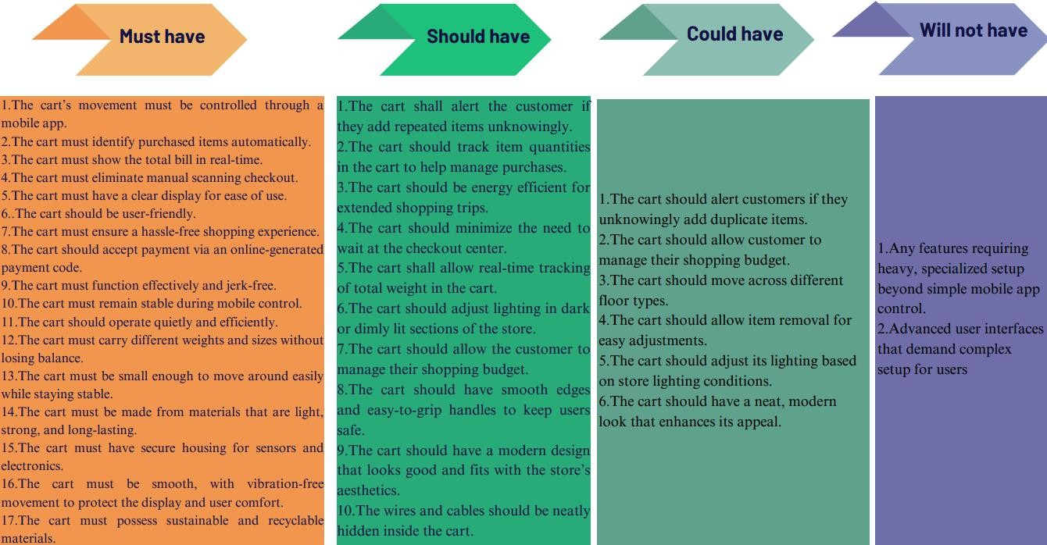

Fig 3.7

The MoSCoW method is a prioritization technique used in project management to categorize and rank requirements. It helps stakeholders understand the relative importance of different features or tasks. MoSCoW is an acronym that stands for:

* + - **Must have:** These are non-negotiable requirements for the project's success. If these aren't included, the project is considered a failure. They are critical for delivery and should be prioritized above all else.
    - **Should have:** These requirements are important but not essential for the project's success. Including them adds significant value, but the project can still launch without them. They are often included if time and resources allow.
    - **Could have:** These are desirable but not critical requirements. They add a nice touch to the project but are often the first to be cut if there are constraints. Including them might increase user satisfaction but isn't crucial.
    - **Won't have:** These are requirements that have been explicitly excluded from the current project scope. This helps manage expectations and prevents scope creep. It doesn't mean they won't ever be included, but they are not planned for the current iteration.

# Mechatronics System Design

## MATLAB requirement toolbox

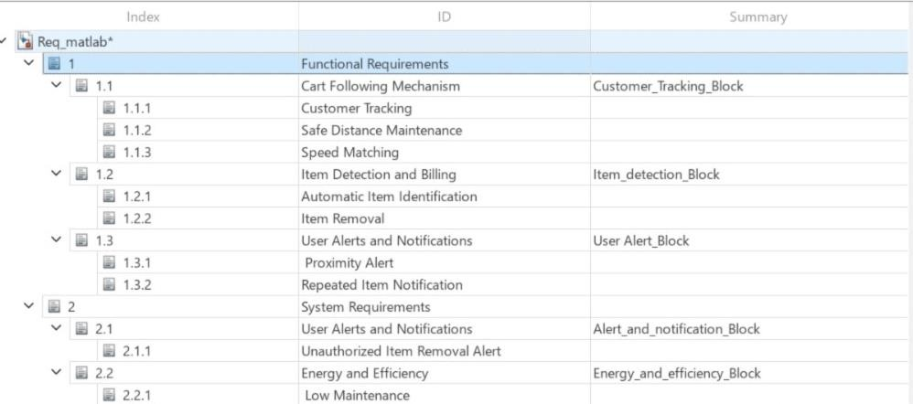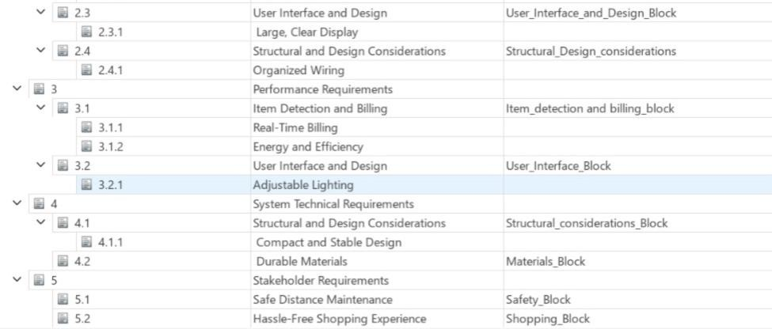

Table 4.1

## MATLAB Architecture

4.2a Logical Architecture

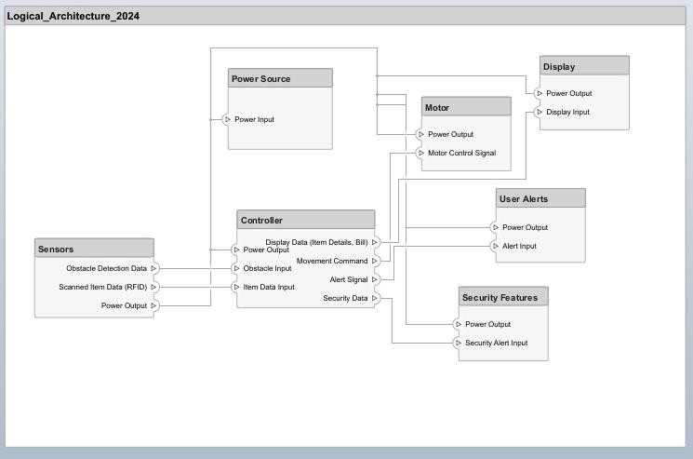

Fig 4.2a

* 1. b Functional Architecture

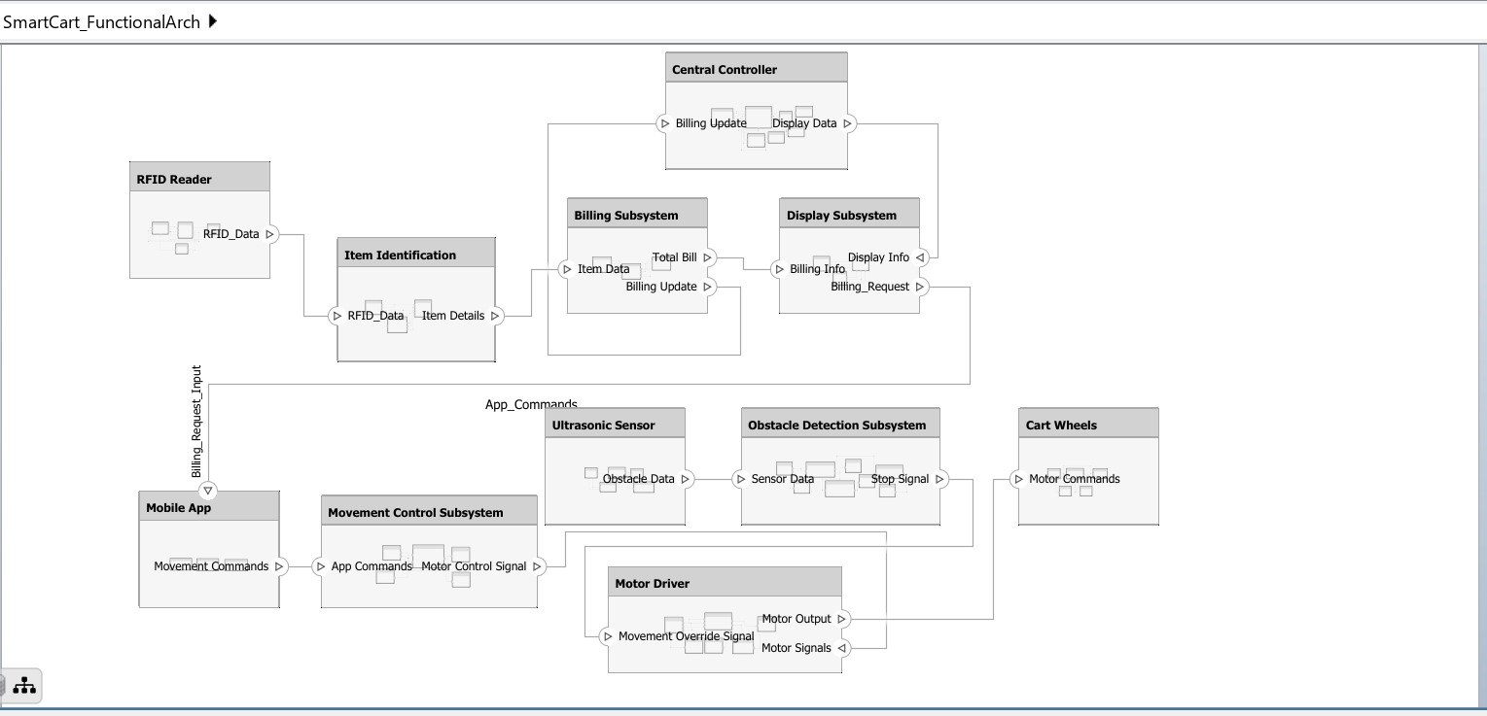

Fig 4.2b

## Morphological chart

|  |  |  |  |  |  |
| --- | --- | --- | --- | --- | --- |
| SI. NO | SUB- FUNCTIONS | MEAN 1 | MEAN 2 | MEAN 3 | MEAN 4 |
| 1. | Movement control | Mobile application | RFID-Based navigation | Joystick-based control | Line Following  ROBOBOX Line Following Robot || Line ... |
| 2. | Item Scanning | RFID Reader module | NFC Reader module | Barcode Scanning  Different Types Of Barcode Scanners? | ASP | QR Code Scanning  Unlocking the Power of QR Code Technology: A Comprehensive Guide |
| 3. | Obstacle detection | Ultrasonic sensor  Robocraze Banggood HC-SR04 DC 5V Ultrasonic Module Distance Measuring Transducer  Sensor : Amazon.in: Industrial & Scientific | IR sensor  VEEROBOT Infrared (IR) Proximity/Obstacle Detecting Sensor Module :  Amazon.in: Industrial & Scientific | LIDAR  LIDAR-Lite v3 - SEN-14032 - SparkFun Electronics | Camera-Based Vision  Vision Systems | KEYENCE India |
| 4. | User Interface | LCD Display | Mobile Application | Touchscreen Display  High-tech shopping carts on the way | Smartwatch interface  Smartwatch Integration Royalty-Free Images, Stock Photos & Pictures |  Shutterstock |
| 5. | Controlling unit | STM32 | ESP32 | Rugged board | Arduino |
| 6. | Actuation | DC Motor | Stepper Motor | Servo Motor | Gear Motor  200RPM DC 3-12V Dual Shaft BO Gear Motor For Arduino Smart Car |
| 7. | User alert | LED Indicators  Amazon.com: Peirdom 10PCS 8mm LED High brightness Round Head Beads F8  Direct Insert Indicator Light(Red emits red light) : Industrial & Scientific | Mobile App Notifications  Ultimate Guide to App Push Notifications | Beeping Sounds  What is the beep sound in a computer ... | Voice Prompts  Voice Prompts | Business Phone Systems ... |
| 8. | Mobility | Standard Wheels  Poly Shopping Cart Wheels ... | Motorized Wheels  Motorized Traction Wheels - Maximum ... | Omnidirectional Wheels  Mecanum wheel Omnidirectional wheel ... | Castor wheel  Shopping Cart Caster Wheel ... |

|  |  |  |  |  |  |
| --- | --- | --- | --- | --- | --- |
| 9. | Item storage | Multiple Compartments  Storage Flat Noodle Holder ... | Foldable/Expandable Storage  Mobile Folding Trolley | Shopping cart ... | Standard storage  Stainless Steel Shopping Mall Trolley ... | Bagging Storage  Inditradition Shopping Trolley Bag ... |

* 1. **Conceptual Designs**

4.4a Conceptual Design 1:

Table 4.3

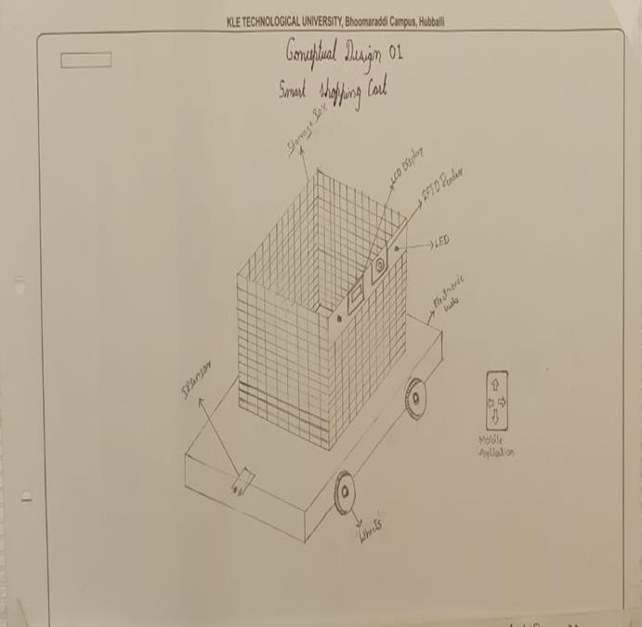

Fig 4.4a

4.4b Conceptual Design 2:

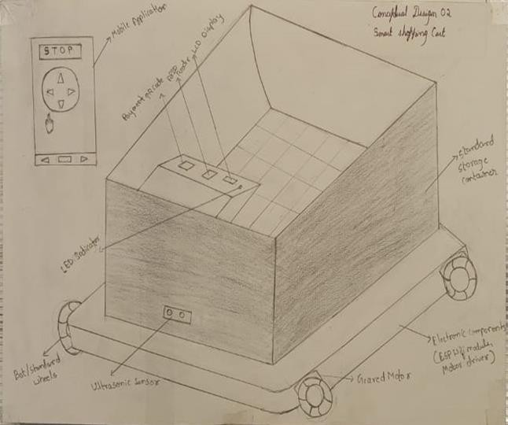

Fig 4.4b

4.4c Conceptual Design 3:

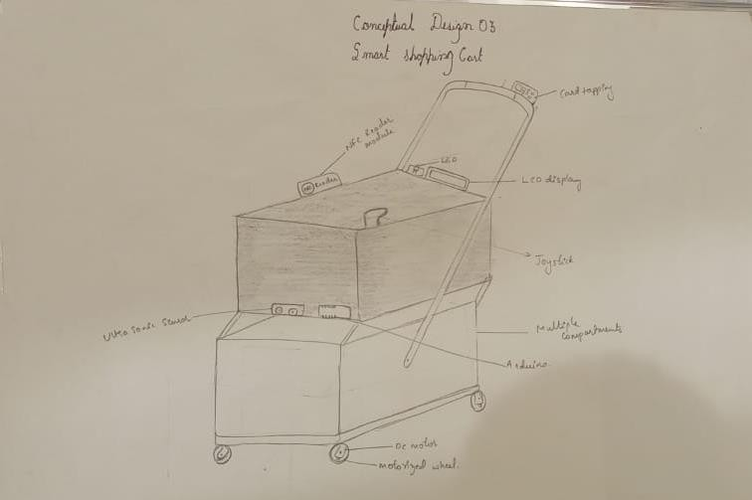

Fig 4.4c

4.4d Conceptual Design 4:

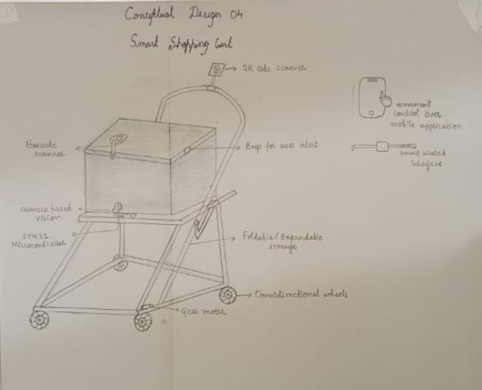

Fig 4.4d

4.4e Conceptual Design 5:

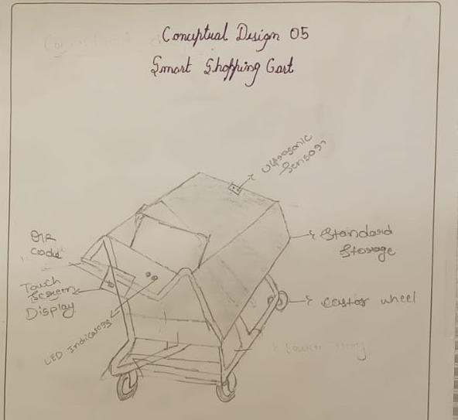

Fig 4.4e

## 4.5 Concept Evaluation

4.5a Concept Screening

|  |  |  |  |  |  |  |  |
| --- | --- | --- | --- | --- | --- | --- | --- |
| SI.NO | Design Objectives | Weights | Design 1 | Design 2 | Design 3 | Design 4 | Design 5 |
| 1. | Ease of use | 10 | + | ++ | ++ | ++ | ++ |
| 2. | Portability | 6 | - | ++ | + | + | - |
| 3. | Use of standard parts | 7 | ++ | ++ | ++ | + | ++ |
| 4. | Cost | 8 | + | ++ | - | ++ | + |
| 5. | Safety | 9 | ++ | ++ | ++ | ++ | + |
| 6. | Accuracy | 10 | ++ | ++ | ++ | ++ | ++ |
| 7. | Reliability | 9 | + | ++ | ++ | + | + |
| 8. | Power Efficiency | 6 | + | ++ | + | - | - |
|  | Score(+) |  | 85 | 130 | 102 | 96 | 80 |
|  | Score(-) |  | 6 | 0 | 8 | 6 | 12 |
|  | Total |  | 79 | 130 | 94 | 90 | 68 |

Table 4.5a

* 1. b Concept Scoring

|  |  |  |  |  |  |  |  |  |  |  |  |
| --- | --- | --- | --- | --- | --- | --- | --- | --- | --- | --- | --- |
| Design Objectiv e | Wei ghts (%) | Desig n 1 | Scor e | Desig n 2 | Scor e | Desig n 3 | Scor e | Desig n 4 | Scor e | Desig n 5 | Scor e |
| Ease of use | 14 | 4 | 0.56 | 5 | 0.70 | 5 | 0.70 | 5 | 0.70 | 5 | 0.7 |
| Portabilit y | 8 | 2 | 0.16 | 4 | 0.32 | 3 | 0.24 | 3 | 0.24 | 2 | 0.16 |
| Use of standard parts | 10 | 5 | 0.5 | 5 | 0.5 | 5 | 0.5 | 4 | 0.4 | 5 | 0.5 |
| Cost | 11 | 4 | 0.44 | 5 | 0.55 | 3 | 0.33 | 5 | 0.55 | 4 | 0.44 |
| Safety | 13 | 5 | 0.65 | 5 | 0.65 | 5 | 0.65 | 5 | 0.65 | 4 | 0.52 |
| Accurac y | 14 | 5 | 0.70 | 5 | 0.70 | 5 | 0.70 | 5 | 0.70 | 5 | 0.70 |
| Reliabilit y | 13 | 5 | 0.65 | 5 | 0.65 | 5 | 0.65 | 5 | 0.65 | 4 | 0.52 |
| Power Efficienc y | 8 | 4 | 0.32 | 4 | 0.32 | 4 | 0.32 | 3 | 0.24 | 2 | 0.16 |
| Total Score |  |  | 3.98 |  | 4.39 |  | 2.94 |  | 4.13 |  | 3.7 |
| Rank |  |  | 3 |  | 1 |  | 5 |  | 2 |  | 4 |

Table 4.5b

4.5c Finalised Concept

4.5c (i) Detailed design

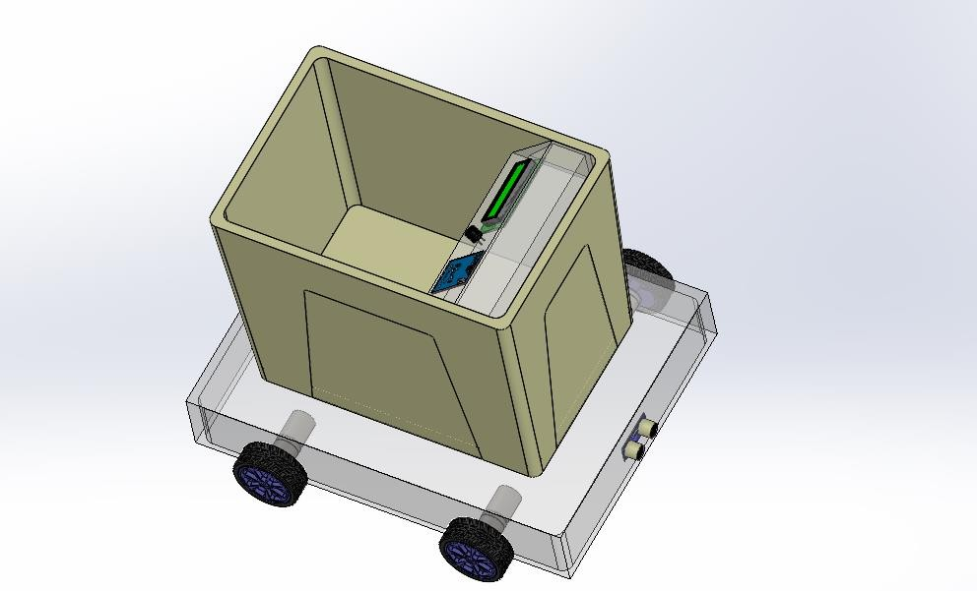

Fig 4.5c (i)

4.5d Part drawings

4.5d(i) Base Frame

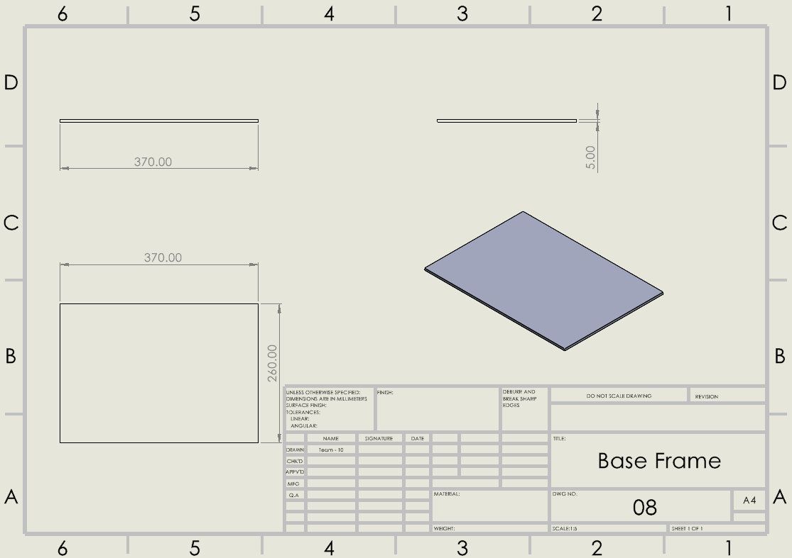

Fig 4.5d(i)

4.5d(ii) Basket

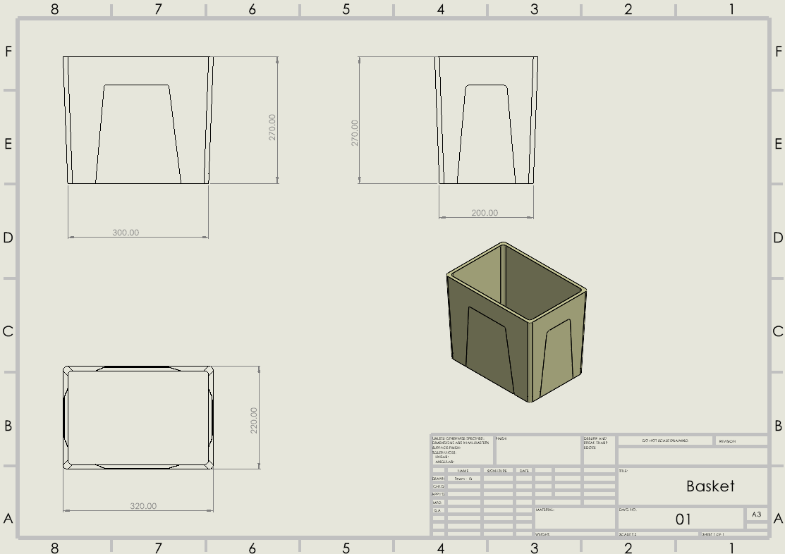

Fig 4.5d(ii)

4.5d(iii) Buzzer

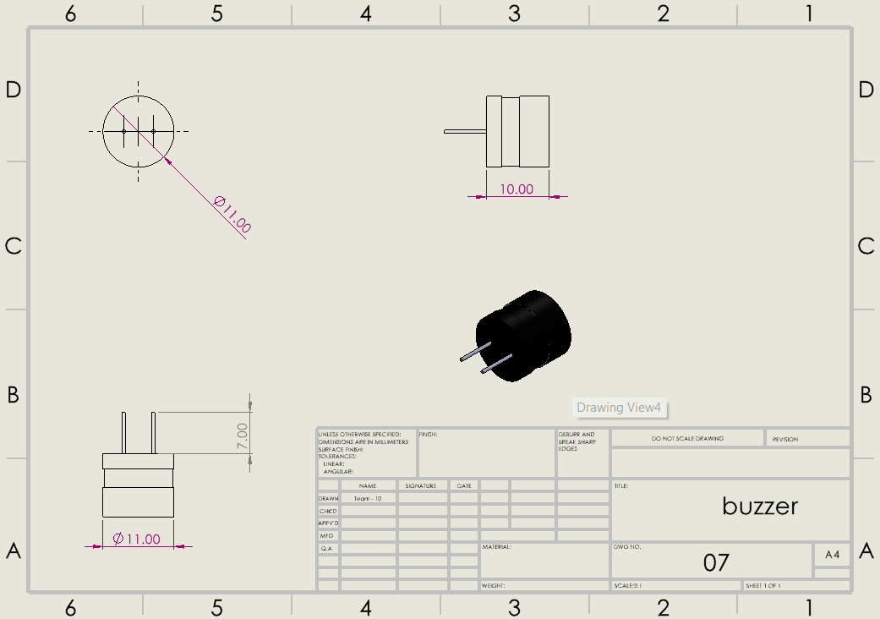

Fig 4.5d(iii)

4.5d(iv) Display Support

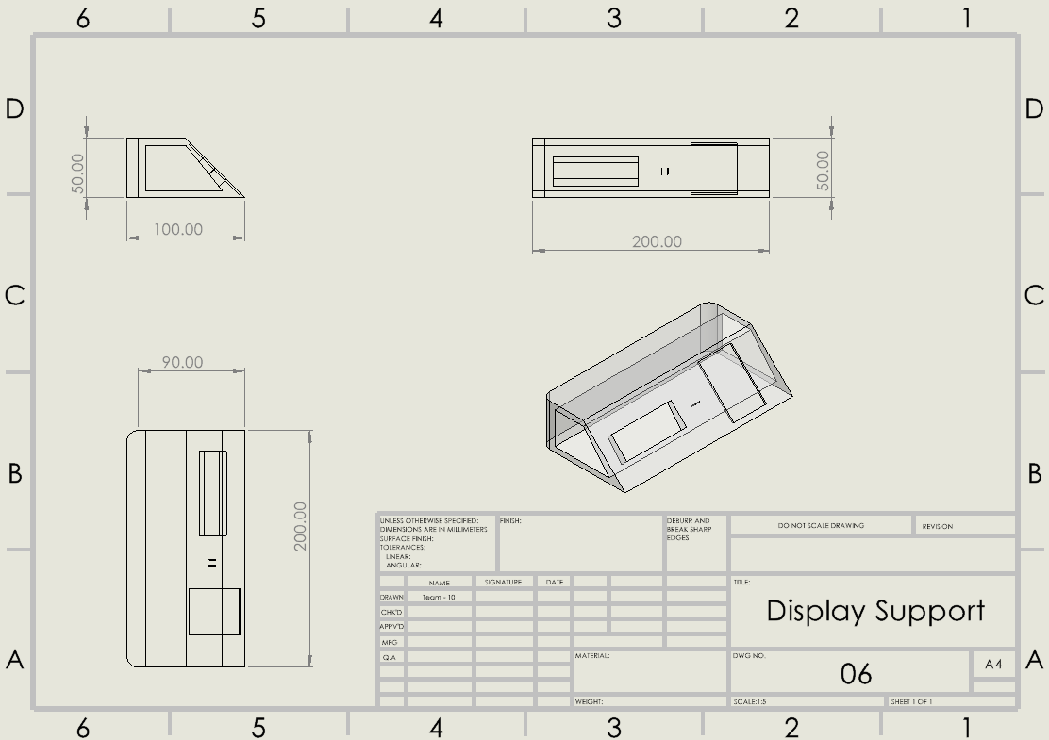

Fig 4.5d(iv)

4.5d(v) Geared motor

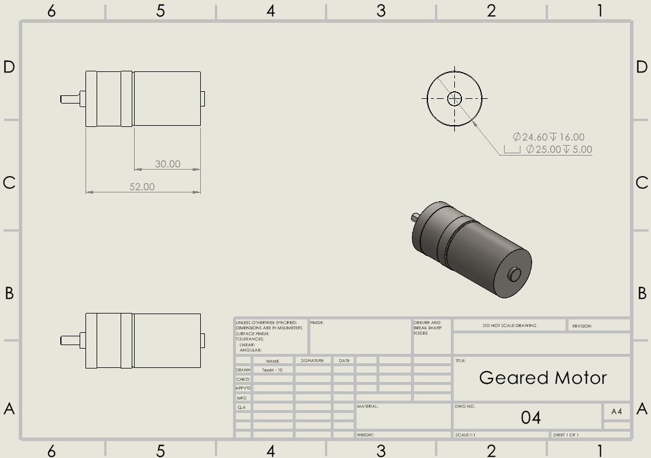

Fig 4.5d(v)

4.5d(vi) LCD Display

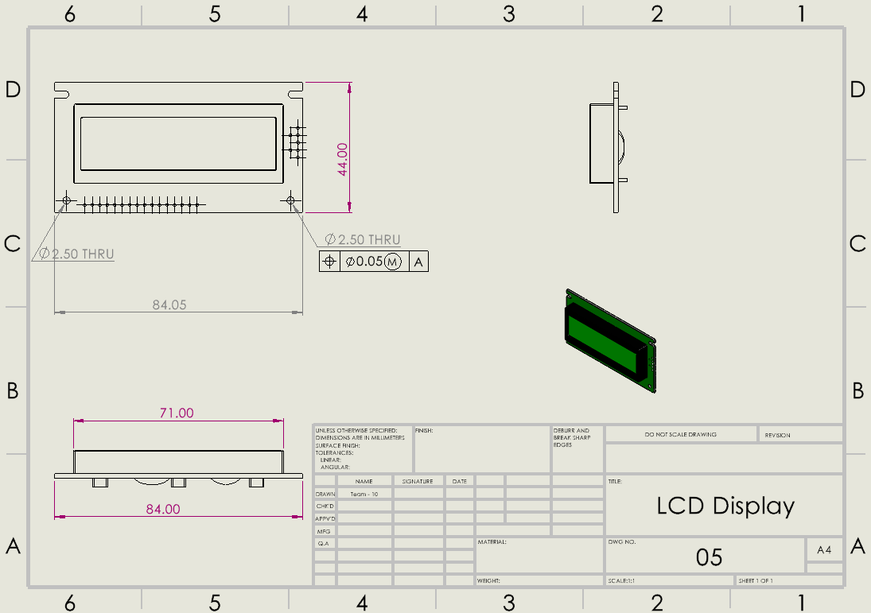

Fig 4.5d(vi)

4.5d(vii) Side frame

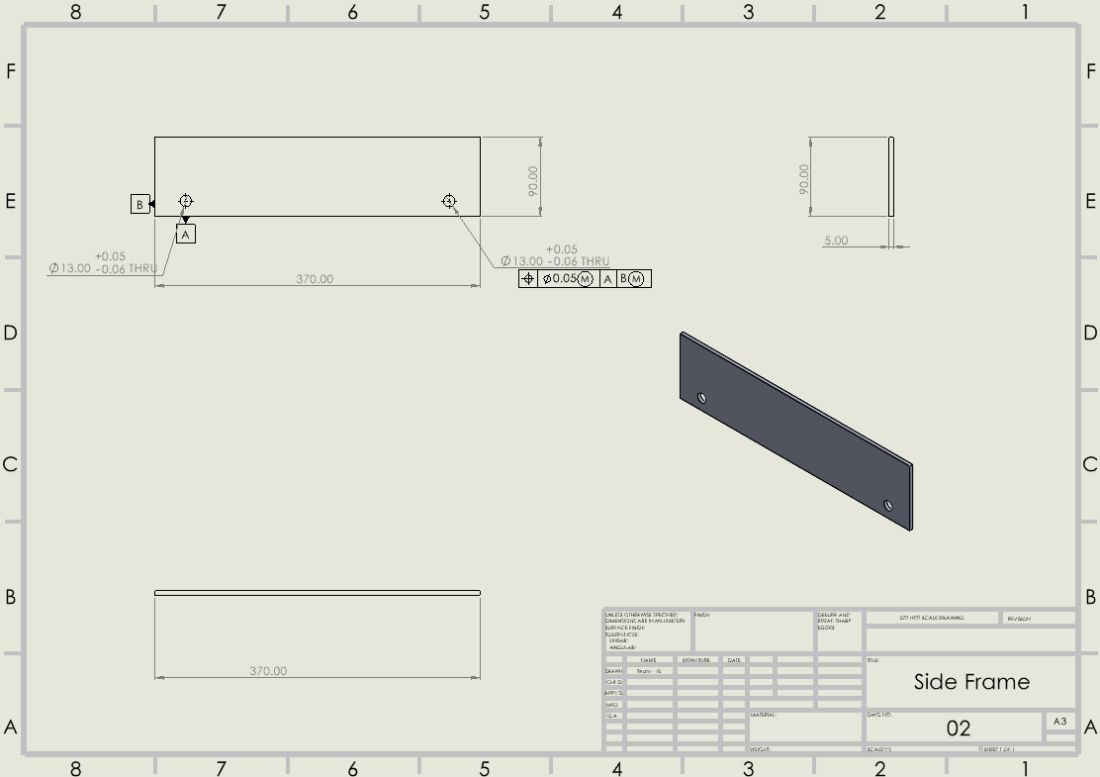

Fig 4.5d(vii)

4.5d(viii) Top frame

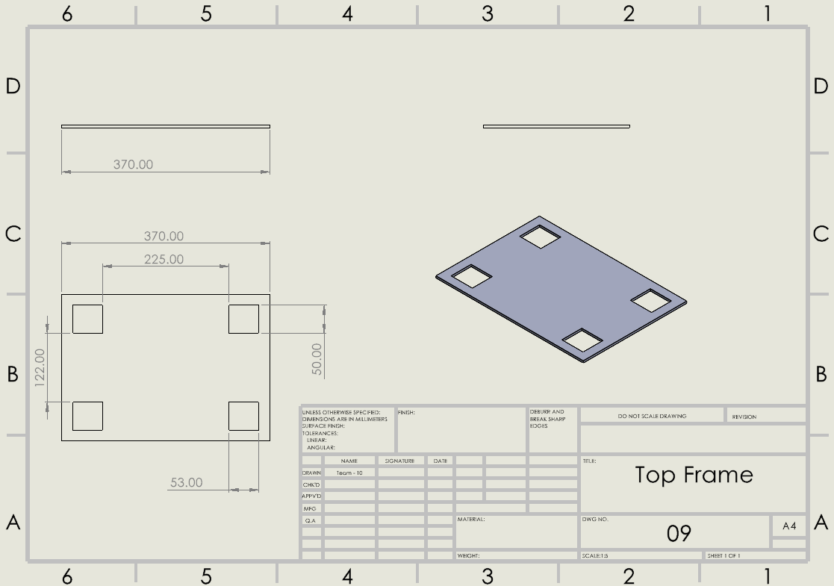

Fig 4.5d(viii)

* 1. d(ix) Ultrasonic sensor

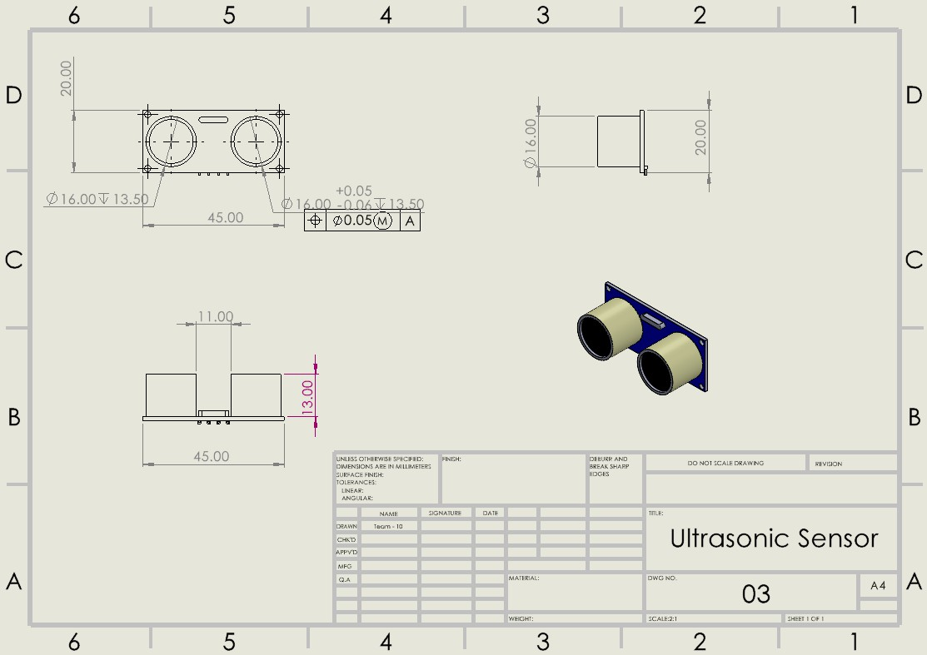

Fig 4.5d(ix)

* 1. Flow chart

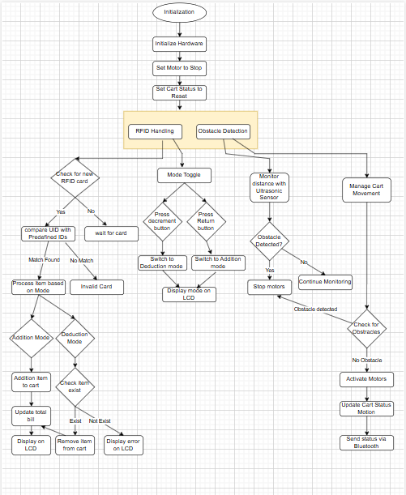

Fig 4.6

* 1. Bill Of Materials (BOM)

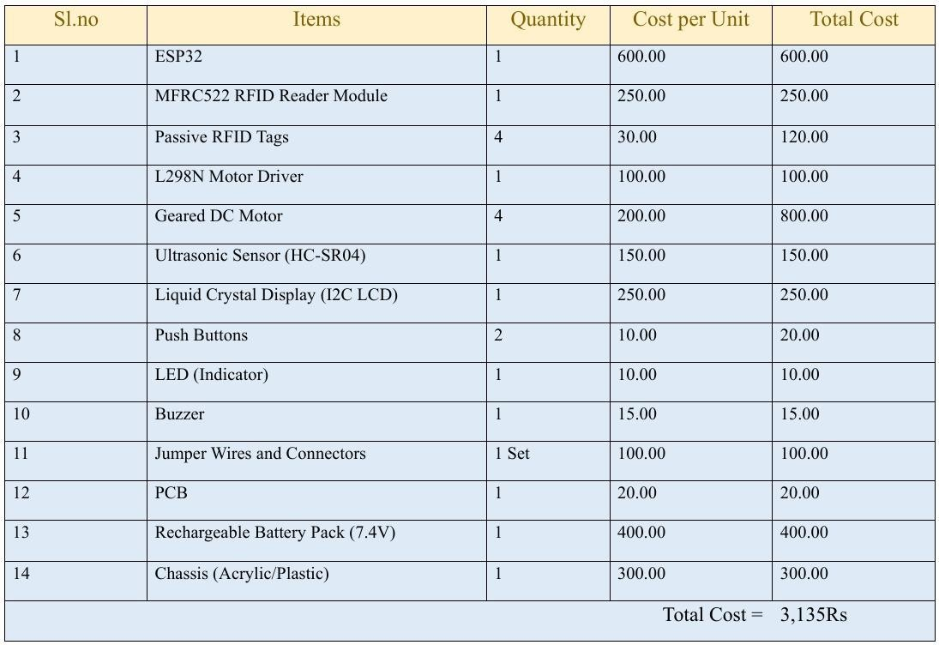

Table 4.7

* 1. Circuit Diagram

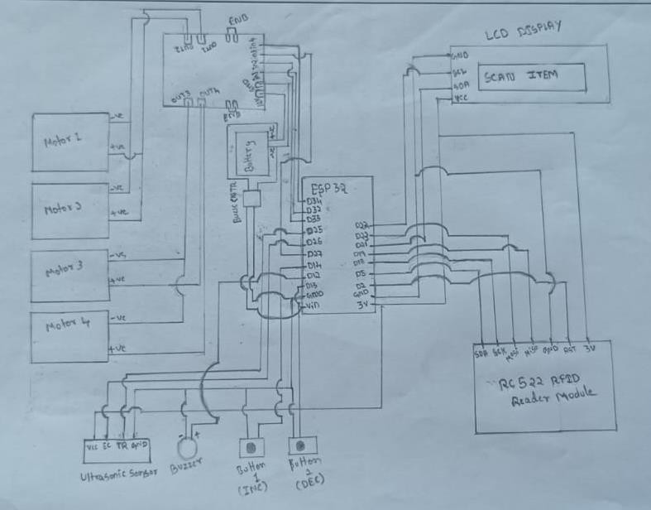

Fig 4.8

## Prototyping

* 1. Images of physical prototype

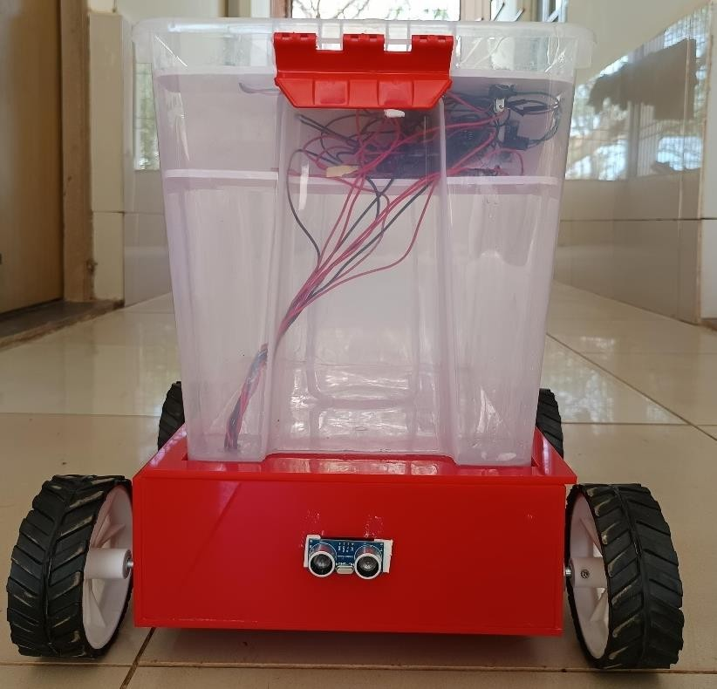

Fig 5.1a

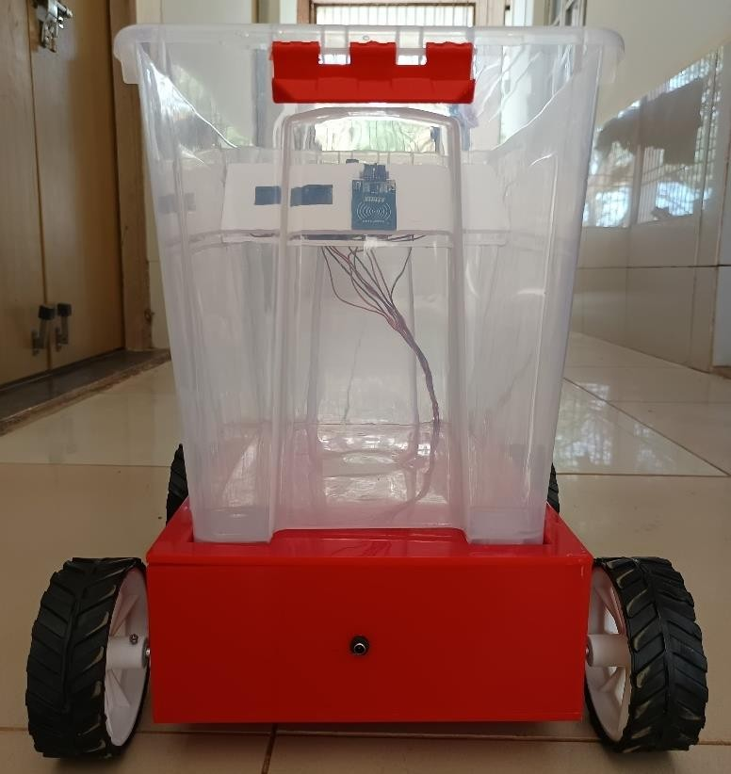

Fig 5.1b

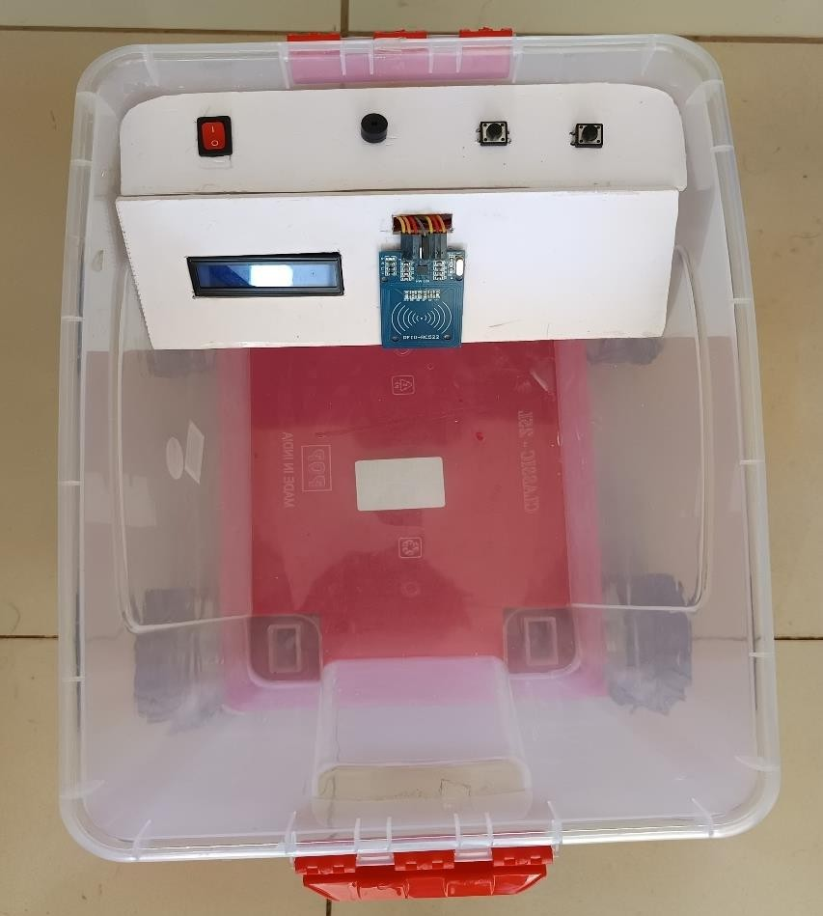

Fig 5.1c

* 1. Images in operating condition with user

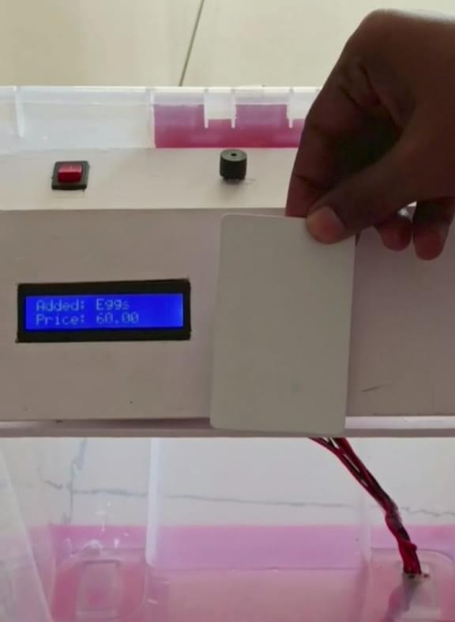

Fig 5.2a

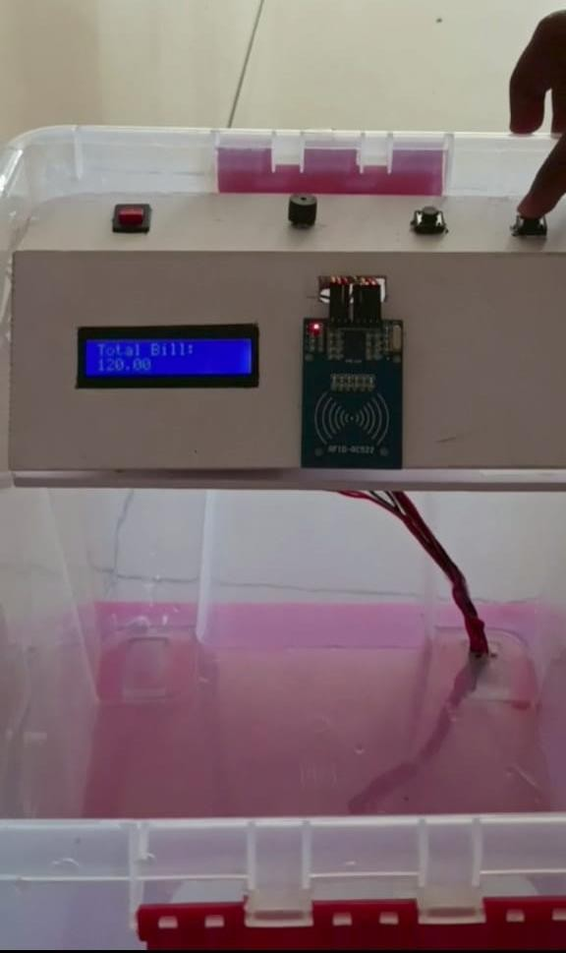

Fig 5.2b

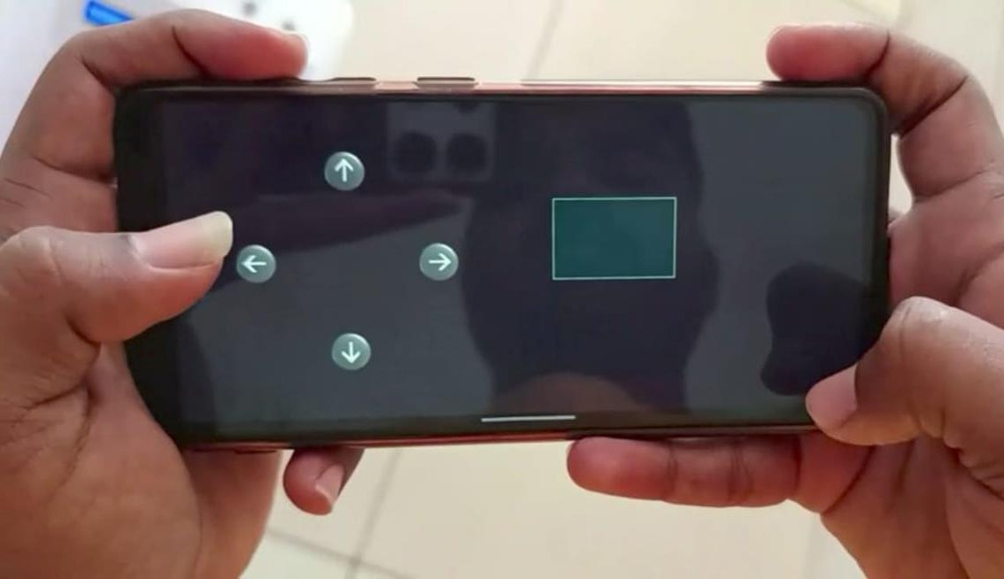

Fig 5.2c

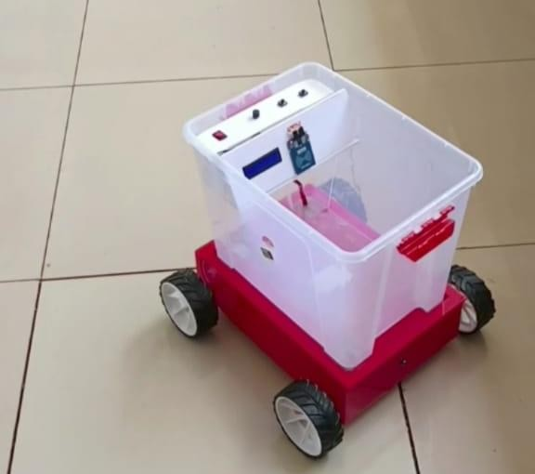

Fig 5.2d

Prototyping and Outcomes

We successfully implemented the Smart Shopping Cart prototype, incorporating key features such as RFID-based item scanning, real-time automatic billing, obstacle detection using IR sensors, and mobile app control. The cart efficiently updates the bill after each item is added, ensuring budget management for users.

The outcomes demonstrate a user-friendly, accessible, and efficient solution that enhances shopping convenience, particularly for elderly individuals, carrying women, and hand- impaired users. The prototype has validated the feasibility of the concept, showcasing automation's potential to improve everyday shopping experiences.

# Testing

Testing: Outcomes and Analysis

During the testing phase of the Smart Shopping Cart, we evaluated the prototype against the requirements generated earlier. Here are the outcomes:

Successfully Met Requirements

1. Must-Have Requirements:
   * RFID-Based Scanning: Successfully implemented; items were accurately scanned, and details like name and cost displayed correctly.
   * Automatic Billing System: The bill updated seamlessly after adding each item, aiding in budget management.
   * Obstacle Detection (Ultrasonic Sensor): The cart stopped effectively upon detecting obstacles at the predefined distance, ensuring safety.
   * Mobile App Control: The cart was controlled efficiently through a mobile application, providing a smooth user experience.
2. Should-Have Requirements:
   * Large Display: A clear LCD display was integrated to show item details and the bill.
   * Energy Efficiency: Optimized power usage of components was achieved through proper circuit design.

Failed Requirements

1. Must-Have:
   * Smooth Movement on Different Floors: The cart struggled on uneven or highly textured surfaces, reducing its performance on certain floor types. Reason for Failure: Limited testing and lack of advanced wheel or motor configuration to handle various surfaces.
2. Should-Have:
   * Expired Product Identification: This feature was not implemented due to time constraints and complexity in integrating product expiration data. Reason for Failure: Dependency on external product databases and the need for additional sensors/software.

The testing phase validated that the cart met most critical requirements and demonstrated its potential to enhance shopping convenience. However, addressing the failed requirements, especially floor adaptability expired item alerts, will further improve the cart's functionality and reliability in real-world scenarios.

# Conclusion

The NextGen Smart Shopping Cart successfully combines innovation and automation to revolutionize the shopping experience, making it smarter, simpler, and more accessible. By integrating RFID-based item scanning, real-time billing, obstacle detection, and mobile app control, the cart addresses inefficiencies in traditional shopping processes while catering to the specific needs of elderly customers, carrying women, and hand-impaired individuals.

This project demonstrated the potential of automation in enhancing convenience, reducing human effort, and ensuring a seamless shopping experience. While most objectives were achieved, further refinements, such as improving floor adaptability and implementing additional features like unauthorized item alerts and expired product detection, can make the system more robust.

Overall, the NextGen Cart stands as a testament to how technology can be utilized to simplify everyday tasks and improve the quality of life for diverse user groups. It provides a foundation for future advancements in retail automation, aligning with the vision of creating smarter and more sustainable solutions for human well-being.

# Team Details

|  |  |  |  |  |
| --- | --- | --- | --- | --- |
| **SI.N O** | **Name** | **USN** | **Mobile.No** | **Email-ID** |
| 1 | Shrinidhi Mudhole | 01FE22BAR015 | 7760054104 | [shrinidhimudhole@gmail.com](mailto:shrinidhimudhole@gmail.com) |
| 2 | Nandeesh Tuppad | 01FE22BAR020 | 7411128977 | [nandeeshtuppad@gmail.com](mailto:nandeeshtuppad@gmail.com) |
| 3 | Vijay Totakar | 01FE22BAR023 | 6363710519 | [vijaytotakar@gmail.com](mailto:vijaytotakar@gmail.com) |
| 4 | Shwetha Halepujari | 01FE22BAR042 | 6361196531 | [shwethahalepujari@gmail.com](mailto:shwethahalepujari@gmail.com) |
| 5 | Koushik Kamble | 01FE23BAR413 | 9632288232 | [Koushikkamble76@gmail.com](mailto:Koushikkamble76@gmail.com) |

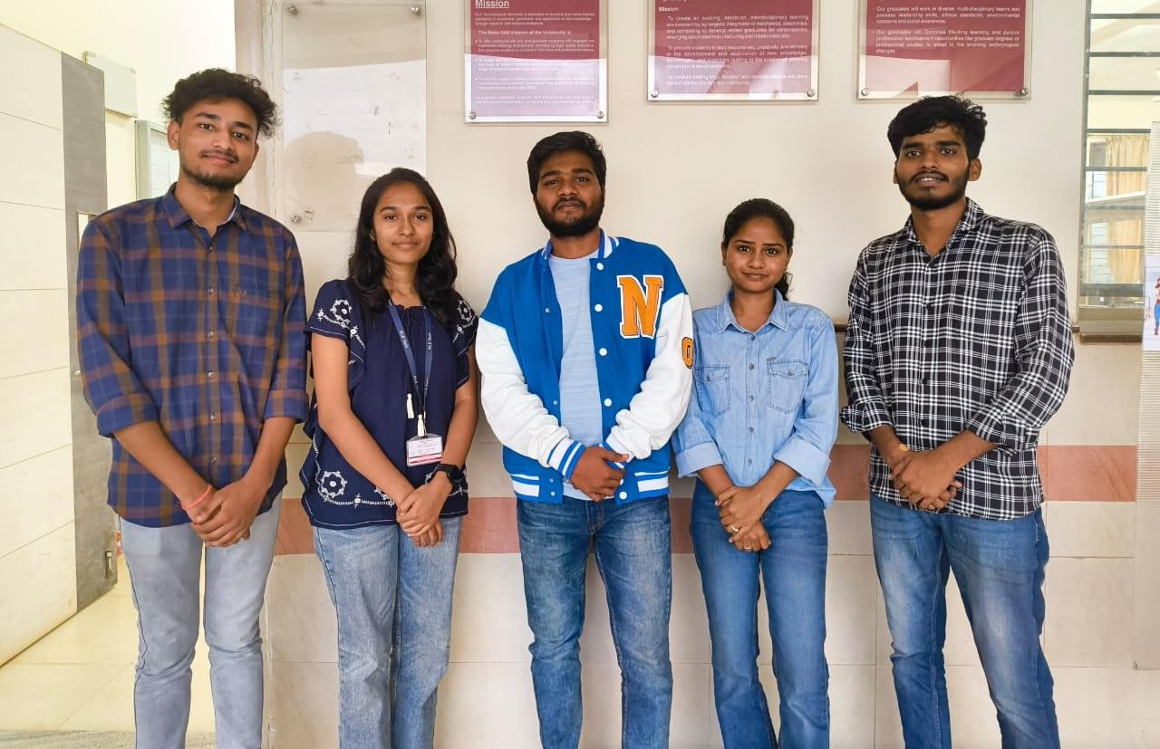

1. **Portfolio**
2. Shrinidhi Mudhole - <https://sites.google.com/view/shrinidhimudhole/home>
3. Nandeesh Tuppad - <https://sites.google.com/kletech.ac.in/nandeeshtuppad/home>
4. Vijay Totakar - <https://sites.google.com/kletech.ac.in/vijaytotakar/home>
5. Shwetha Halepujari - <https://sites.google.com/kletech.ac.in/shwethashalepujari/home?authuser=1>
6. Koushik Kamble - <https://sites.google.com/kletech.ac.in/koushikkamble/home?authuser=1>